**Name: Jatin**

**ID: 3157521**

**Title: Cargo Services**

**Task 1 - Identify the problem**

**Call Discussion with Client: Robin**

I'm setting up the matter call account with Robin. He is running business 'Freight Services'. he really wants a product to keep up with the records of his clients. He needs to keep up with every one of the parts in his business where he is dealing with such countless issues to keep up with the record. he generally burns through such a lot of time to observe the customer subtleties from duplicates and enlists and now and again he lost the records. so he needs to confront such countless hardships to keep up with the record for future. So he really wants an application for the record maintencewhere he can see on which date he has case in court and with which customer.

**Task 2 - Define and document requirements**

Requirement of The Software

Scope of Work

*Features: I will make programming of on Cargo Services. Which will be completely robotized and robin can keep up with and store the information for future. He can see every one of the clients and Bookings through this application on the web. This application would be completely get. Information will be saved in the future effectively. Also no unapproved individual can make changes in it. So Application would be extremely compelling and proficiency.*

*Functional Requirements: Demanded requirements by end user:-*

1. *He wants customermodule save update and delete and list of customers to view.*
2. *Then he wants driver module in the software.*
3. *He wants vehicle type module in the software.*
4. *He wants the record of vehicles.*
5. *He wants login and logout facility in the software.*

*Non-functional requirements:*

1. System should be portable.
2. System should be reliable.
3. System should be secure.
4. Performance of system should be good.
5. System should be flexible.

Time: It will take minimum 20 days to complete.

Total Hours 17 Hours

Designing = 7 hours

Development = 10 hours

The 4 essential steps of the Risk Management Process are:

1. Identify the risk.
2. Assess the risk.
3. Treat the risk.
4. Monitor and Report on the risk.

Cost: $350

Per hour price 18dollars

Total Developing Cost: 18*17=306 Dollars

Hosting Cost = 44 Dollars

Total = 350 Dollars

Project management:-Project management is the science and art of organizing all the components of a project. For example, the launching of a new service, a marketing campaign, or the development of a new product are projects. In fact, even a wedding is a project that requires management.

# Colour Schema

Colours Used : Yellow, Blue and White for Background Black for Text

**Task 3 - Design mockups**

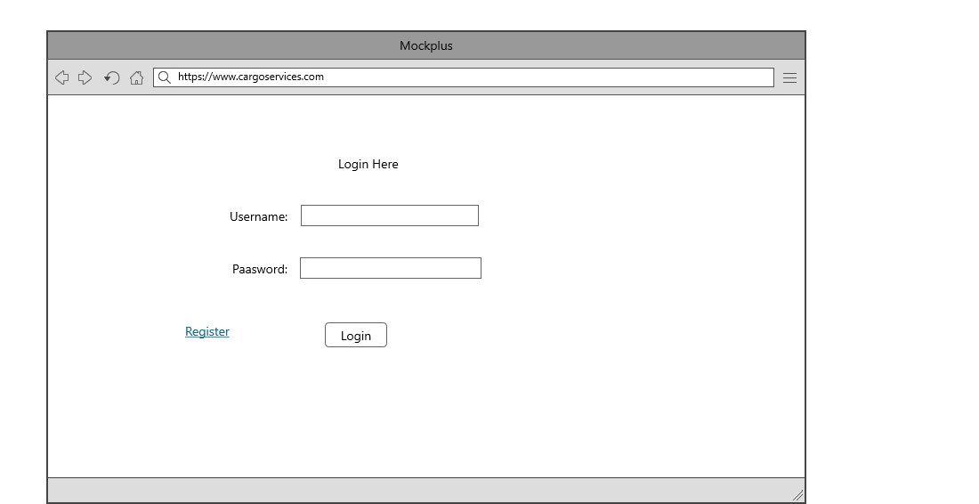

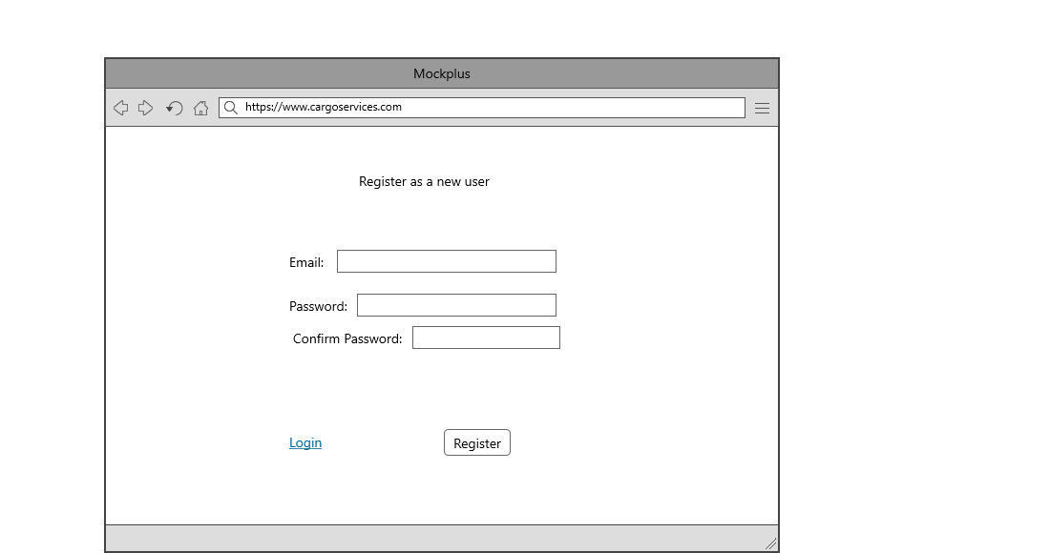

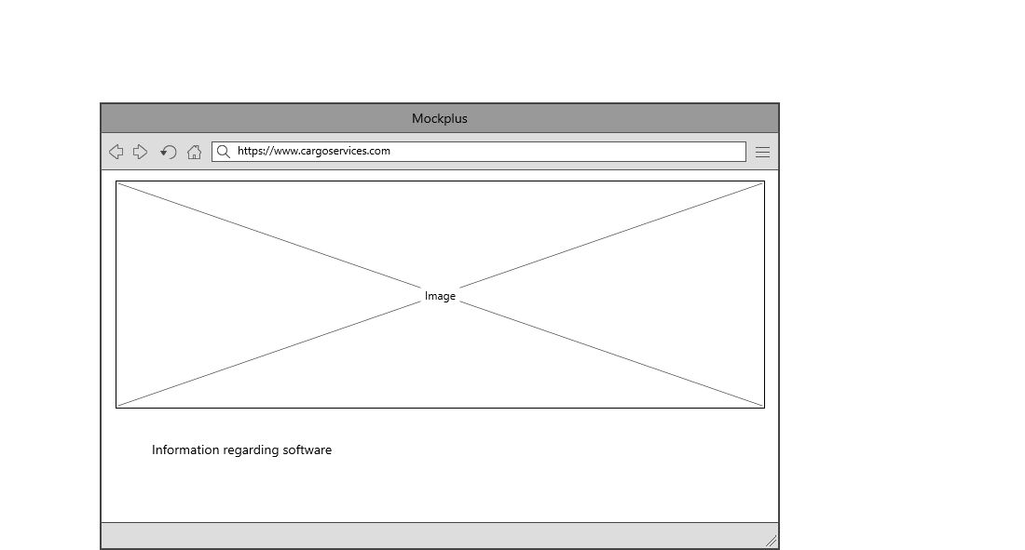

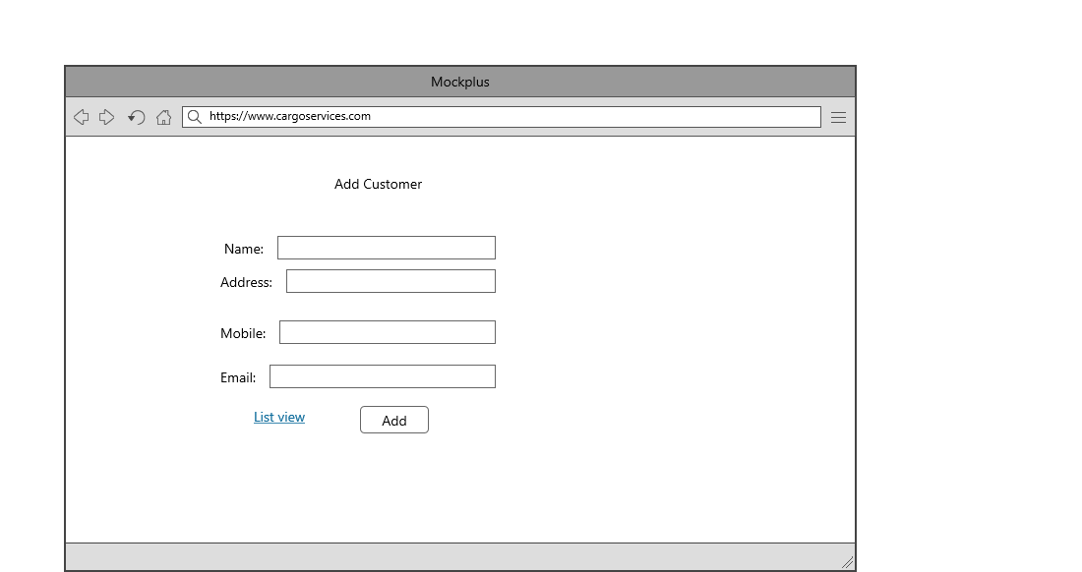

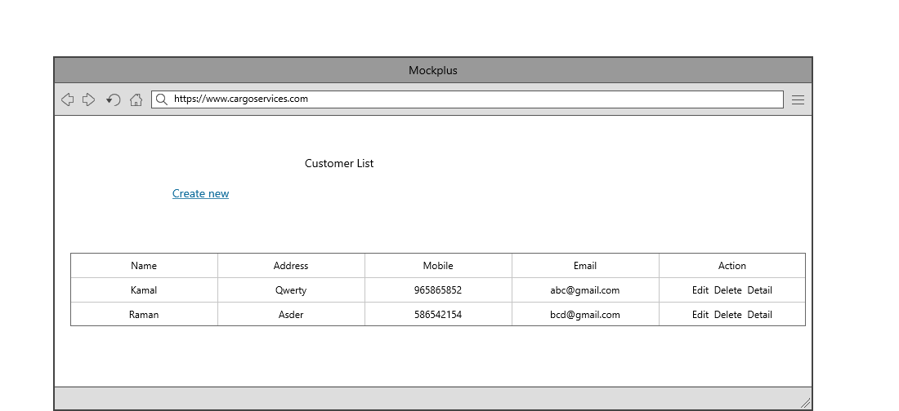

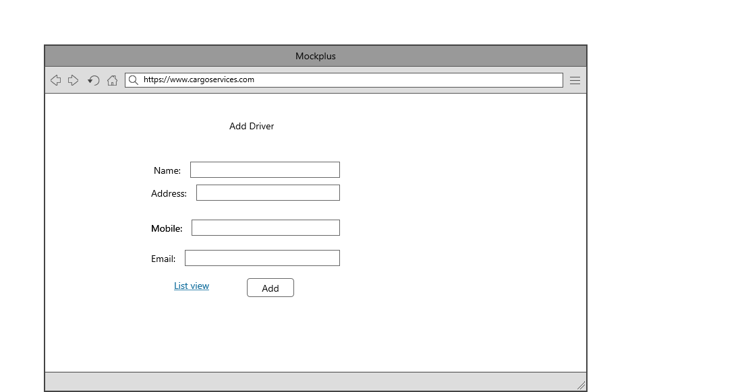

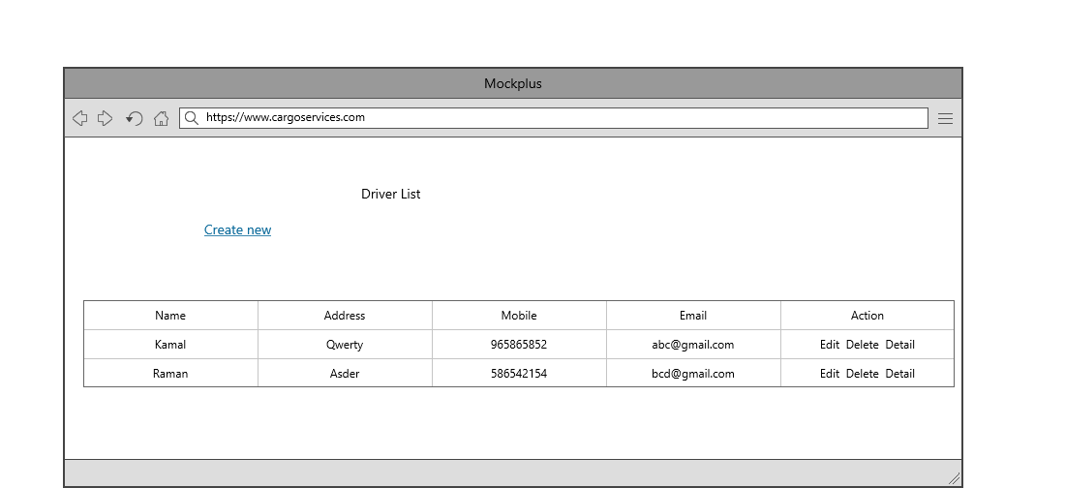

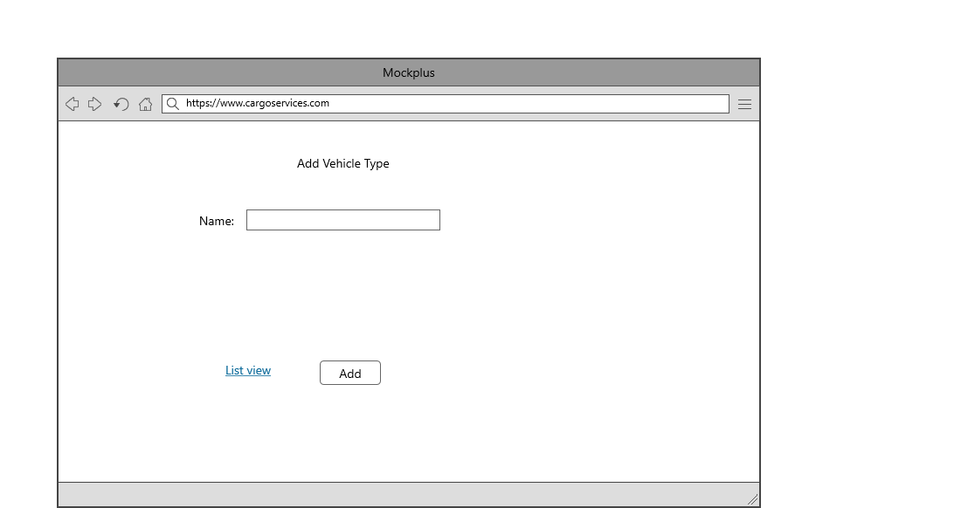

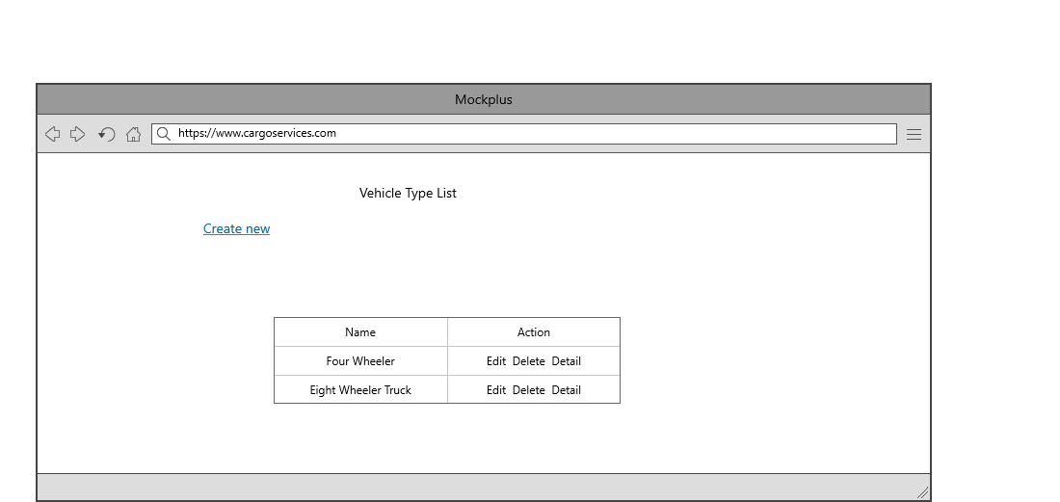

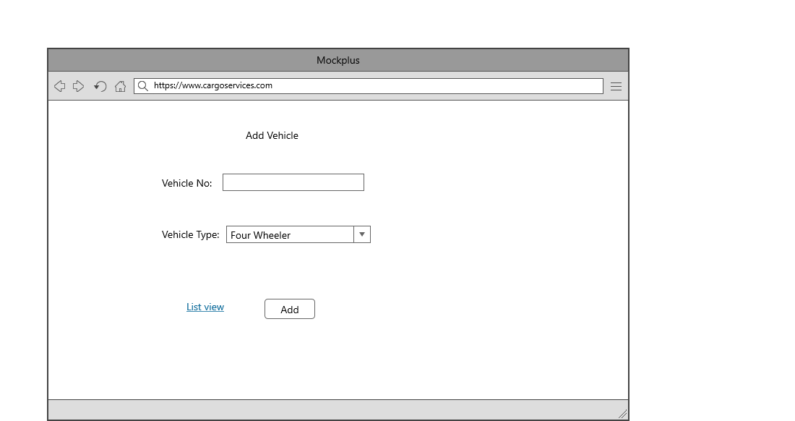

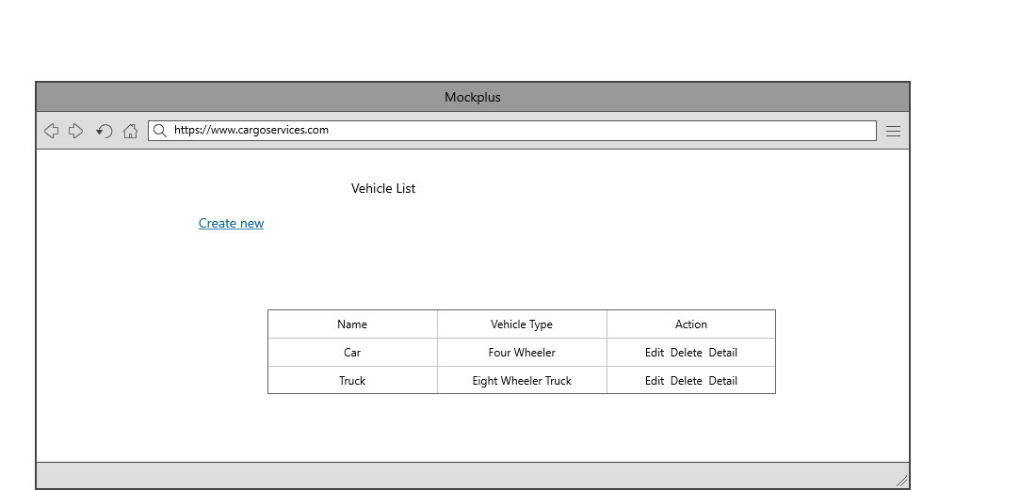

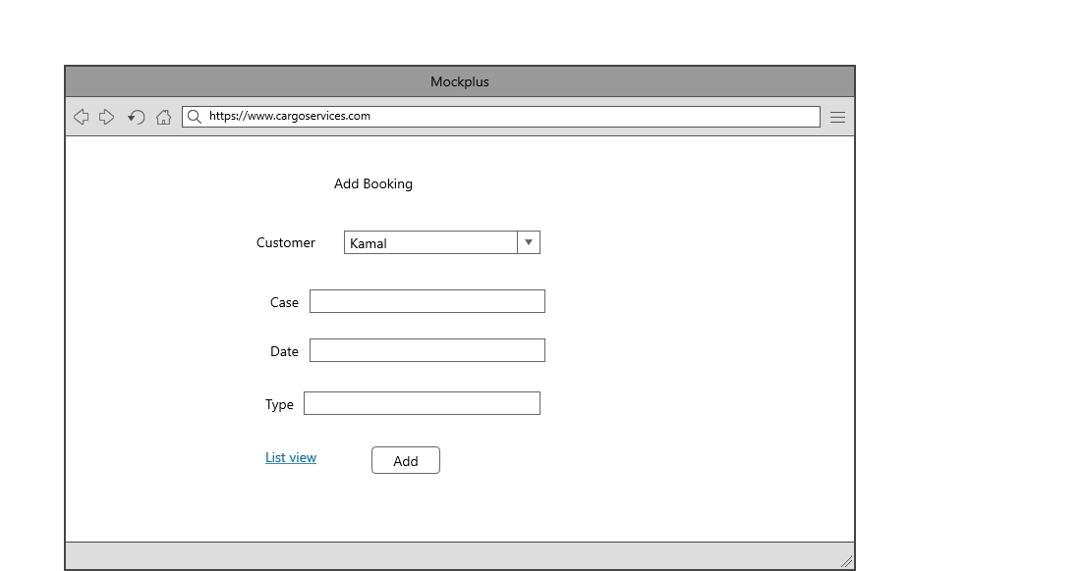

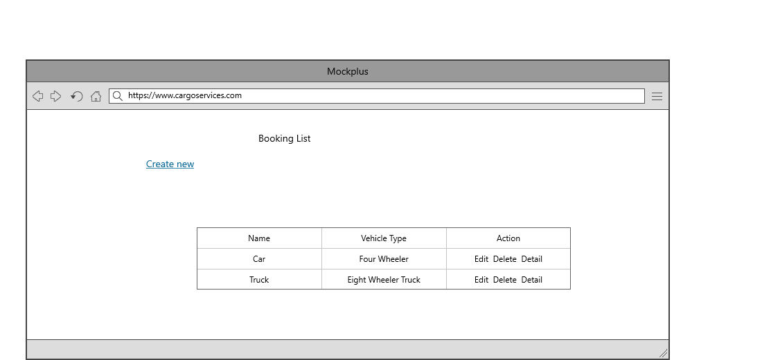

## Task 5- usability testing

|  |  |  |  |  |  |
| --- | --- | --- | --- | --- | --- |
| **User #** | **Login form** | **Customer form** | **Booking Module** | **Pass / Fail / Not executed / Suspended** | **Reviews** |
| Robin | Looking pretty | Very Nice | As Expected perfect | Pass | All modules are ok |
| Manjit | Nice | Role based is good | Very Attractive | Pass | all modules are as expected |
| Sawan | might be more attractive | Very Good | should some changes and expand more | Pass | Login form should be more attractive |
| Sharan | Its ok | Ok | Perfect | Pass | Perfect Software |

**Task 6 - Meet with your client**

Client Meeting:

|  |
| --- |
| Meeting Details |
| * Date and time: 25-Oct-2021 * Location: Newzealand |
| Attendees: Jatin and Robin |
| Agenda: Discussion of Software of Cargo services |
| Discussion (Important Points): He needs customer and booking module on the highest priority. Left requirement is written on above. |
| My To Dos (Actions): Firstly I have to make the mockups of the application. Then Starting the application after the next meeting. |
| Questions requiring Follow- Up: Discussion of the mock ups |
| Comments: Robin is good person and he described regarding software very wisely. |
| Next meeting  Date and Time: 1- Nov-2021 1:00 Pm  Location: Newzealand  Agenda: Showing the mock ups to the client and discussion about further development. |

**Appendix 3**

**Client Review Form**

My developer’sname: Jatin

This form is intended to let you review the communication skills of your developer for this assignment. Your review will partly count towards their final mark. Do not take into account technical skills.

# Grading scale

You must grade your developer for each item listed in the tables below. 1 being the lowest, 5 the highest.

|  |  |  |  |  |
| --- | --- | --- | --- | --- |
| **1** | **2** | **3** | **4** | **5** |
| Strongly disagree | Disagree | Ok | Agree | Strongly agree |

# Review your developer

|  |  |  |
| --- | --- | --- |
| **Item** | **Grade** | **Comment** |
| Communicated clearly and effectively | 2 |  |
| Kept you informed of the progress | 5 |  |
| Met timelines | 4 |  |
| Responded promptly to problems | 3 |  |
| Met overall project objectives | 1 |  |
| Was open to new ideas and suggestions | 5 |  |
| Was easy to work with | 5 |  |

Comments

Provide any extra comments on your developer’s communication skills and professionalism.

Jatin is good developer. He is very good in his work. I proud to get my work completed by jatin.

## Signed by Client

|  |  |
| --- | --- |
| **Signature: Robin** | **Date: 13-nov-2021** |
| **Name: Robin** | **Title:Cargo Services Software** |
| **Contact details (email/Tel):** | |

**Task 8 - Software development life cycle stages**

**Planning :-** The project management plan should:

1. Define project schedule
2. Identify the resource requirement and allocated resources
3. Define Breakdown of tasks and their dependencies
4. Include cost estimation and project budget plan
5. Provide cost and schedule performance measurement
6. Schedule Milestones and reviews
7. Include an acquisition plan to define how the needed resources will be obtained and when

**Requirement :-** In order for Requirements Analysis to begin, there must be an approved Project Charter. The scope of the project will be understood and stated in the Project Charter. The roles and responsibilities for the various activities in the Development Life cycle will be known.

**Software Design and prototyping:-**

Framework configuration archives mirror a frameworks engineering, the construction of the parts of a program or framework, their interrelationships and the standards and rules administering their plan and advancement over the long run. Connections are both run-time and non run-time and subsequently design is likewise communicated as far as parts and connectors. A framework design isn't just a result of necessities yet similarly an aftereffect of hierarchical objectives, the modeler's experience and her specialized climate.

**1. Register Page: -** This is Register page in where you can register new user

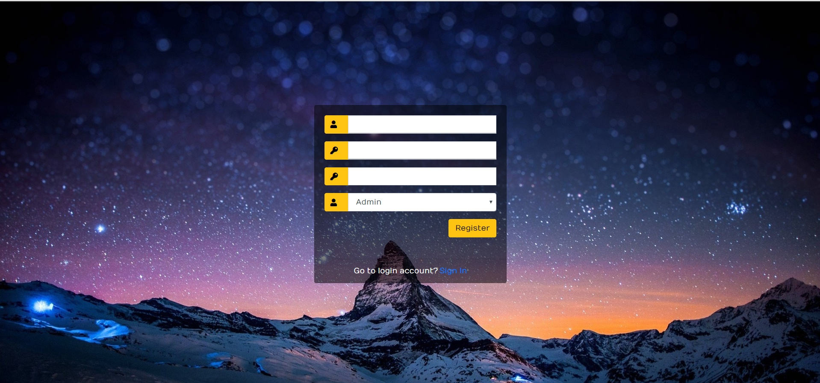

**2.Login Page: -** This is Login page of our website. In this page I can login as a Admin oras a Manager.

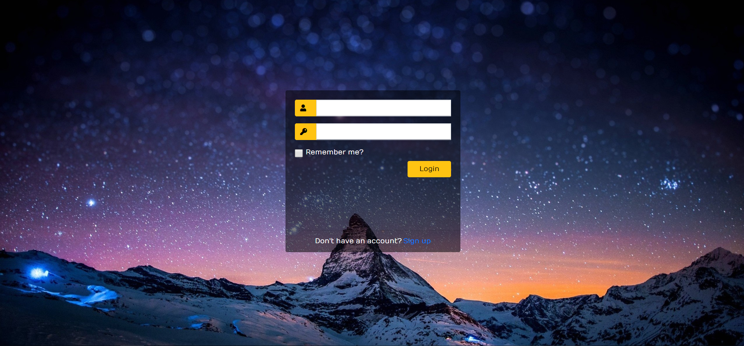

**3. Admin Login**: When admin logins then he can access the all modules of website. Which are shown in the picture.

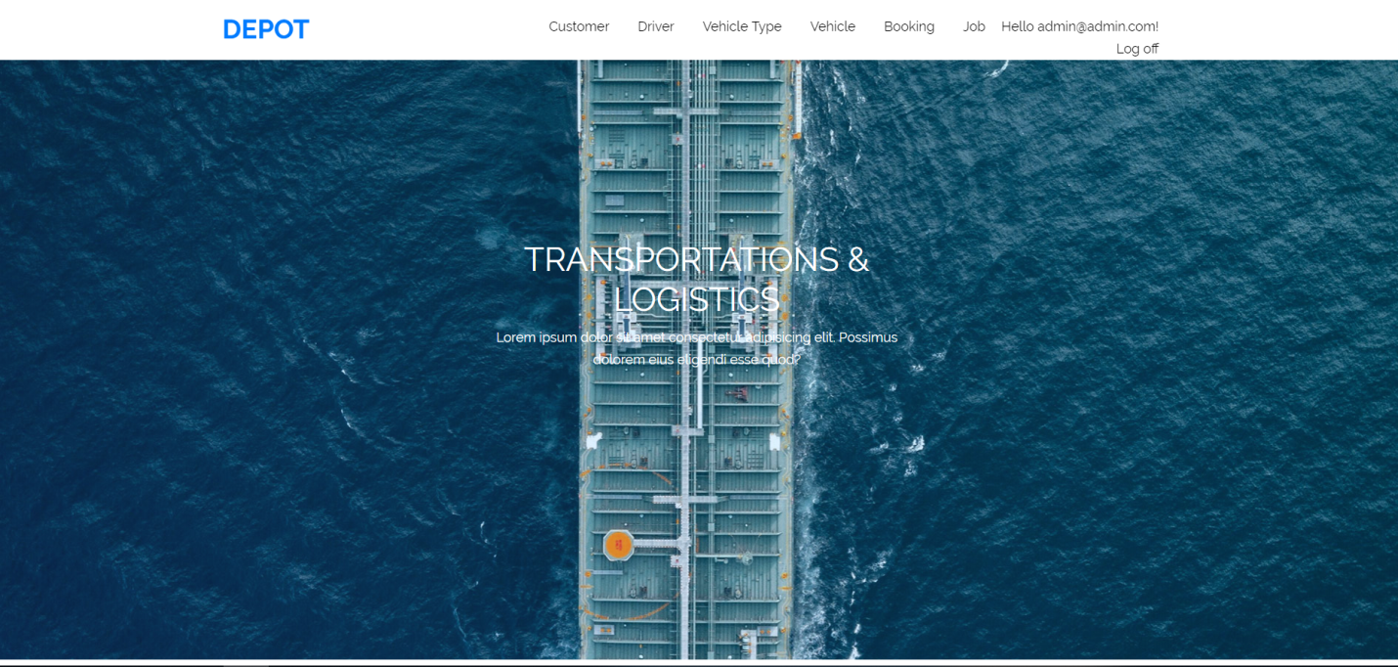

**4. Customer: -** Here I can show the customer in my website. And clicking on the create new link I can create the customer. Edit and delete customer are also available here.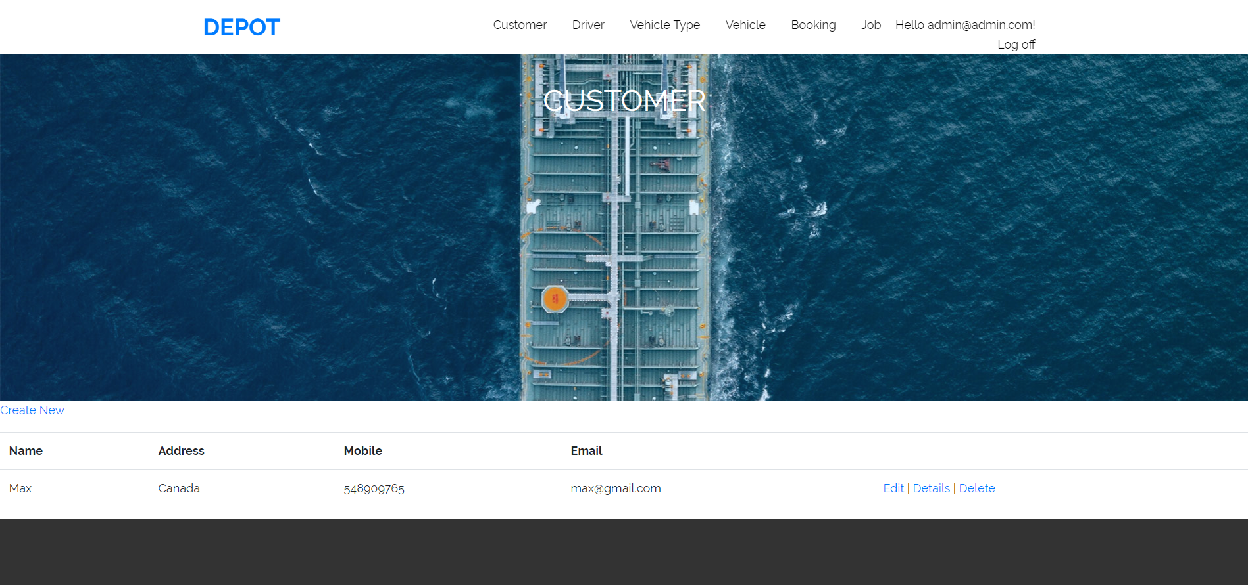

**5. Driver: -** Here I can show the driver in my website. And clicking on the create new link I can create the driver. Edit and delete driver are also available here.

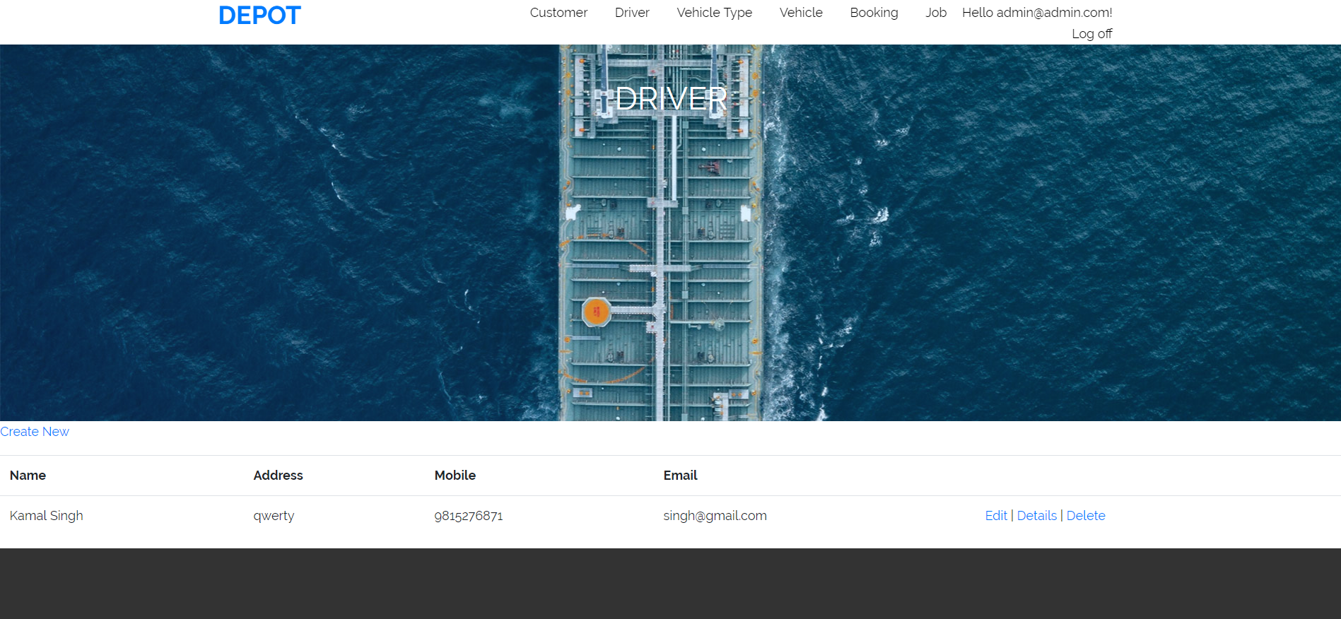

**6. Vehicle Type: -** Here I can show the vehicle type in my website. And clicking on the create new link I can create the vehicle type. Edit and delete vehicle type are also available here.

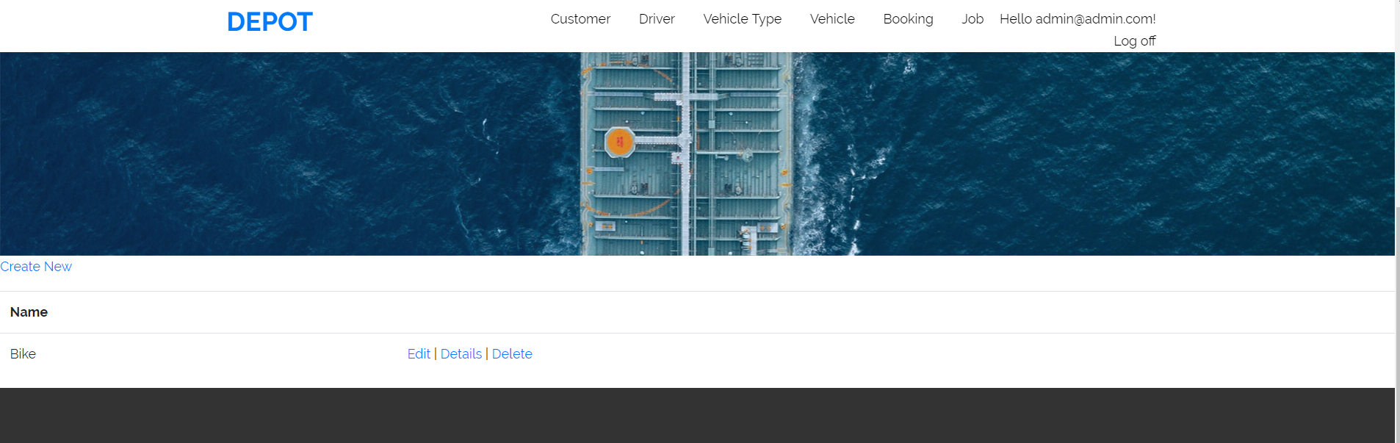

**7. Vehicle: -** Here I can show the vehicle in my website. And clicking on the create new link I can create the vehicle. Edit and delete vehicle are also available here.

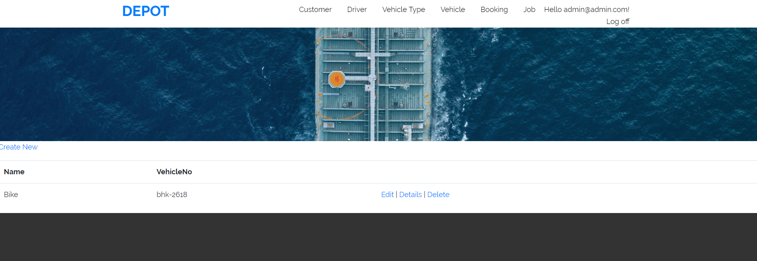

**8. Booking: -** Here I can show the booking in my website. And clicking on the create new link I can create the booking. Edit and delete booking are also available here.

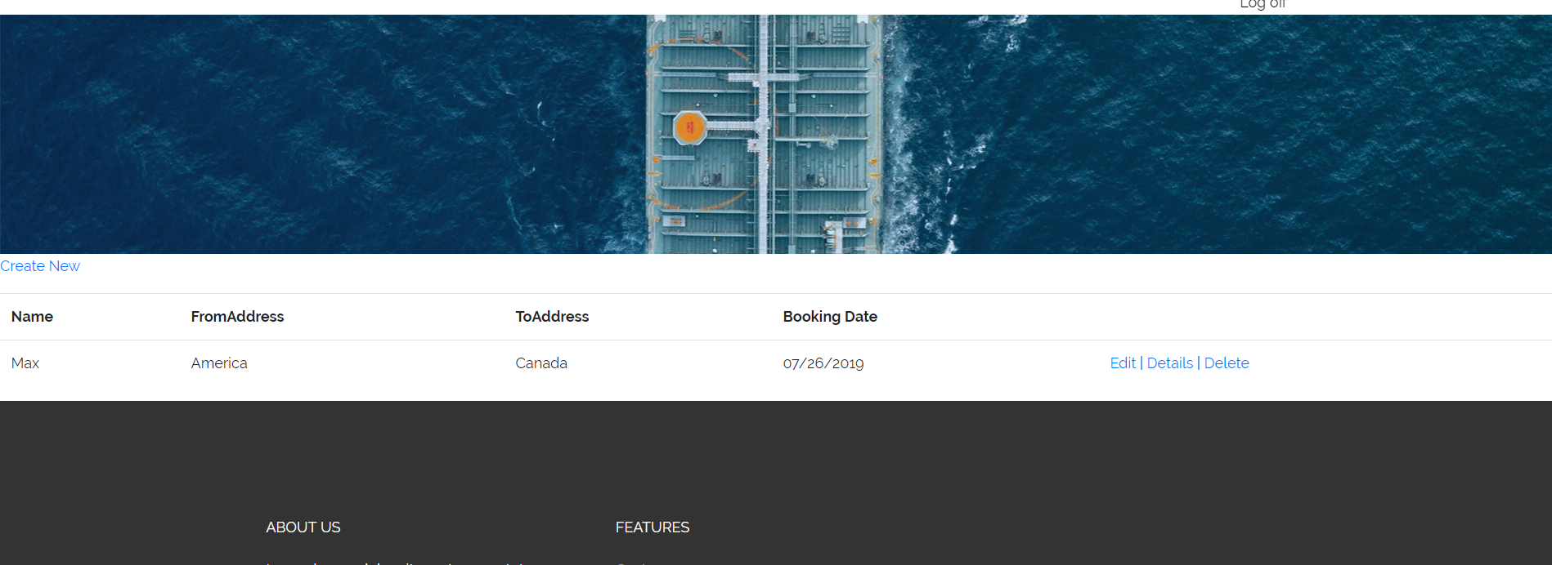

**Software Development:** We know we are ready to commence the software construction work if:

Planning: First Meeting with client discussed about the site and planned what to include and exclude

Requirement : General Specs discussed of running and developing the website

Softaware Designing : General Mocups were approved before coding

1. Technical specifications (SDD) are available.
2. Architecture is proven and signed off by the stakeholders.
3. Unit testing components ( test requirements, scripts, results, time-lines, cases, reports) are completed in the Master Test Plan Document.

**Testing:** The objective of this phase is to perform system integration testing of the developed system. The systems integration test function is to ensure that the developed systems meet all the technical requirements with the components and subsystems integrated. The system test may require any number of additional tests depending on the scope and complexity of the requirements; examples include: security, conformance, accessibility, performance, stress, compatibility, and regression tests.

**Task 9- Project management**

The starting point in discussing how projects should be properly managed is to first understand what a project is and, just as importantly, what it is not.

People have been undertaking projects since the earliest days of organized human activity. The hunting parties of our prehistoric ancestors were projects, for example; they were temporary undertakings directed at the goal of obtaining meat for the community. Large complex projects have also been with us for a long time. The pyramids and the Great Wall of China were in their day of roughly the same dimensions as the Apollo project to send men to the moon. We use the term “project” frequently in our daily conversations. A husband, for example may tell his wife, “My main project for this weekend is to straighten out the garage.” Going hunting, building pyramids, and fixing faucets all share certain features that make them projects.

A project has distinctive attributes that distinguish it from ongoing work or business operations. Projects are temporary in nature. They are not an everyday business process and have definitive start dates and end dates. This characteristic is important because a large part of the project effort is dedicated to ensuring that the project is completed at the appointed time. To do this, schedules are created showing when tasks should begin and end. Projects can last minutes, hours, days, weeks, months, or years.

So I have learnt many things from this project. I never think a lot of knowledge with project work I cab get in software. Now I can get job in IT easily.